# Technical Memorandum/Internal Working Draft 1.01

# Subject: Subject: Population’s Exposures to Pollens in Different Climate Zones in United States

Version: Working Summary Version 1.0

From: Kun Mei

To: Dr. Panos G. Georgopoulos ,YongZhang

Date: Nvo 20, 2013

**1 Introduction**

Airborne allergenic pollen, which has been found to act synergistically with common air pollutants, such as ozone, will cause allergic airway disease (AAD). its distributions exhibit considerable variability in space and time. We can display both the temporal and spatial distributions based on either the mechanism models or statistical models using VERDI and Matlab. Then we use Monte-Carlo method to predict the exposure effect of the pollen in different areas.

**2 Methods**

**2.1 model**

**Data Collection**

Observed airborne pollen counts were obtained from monitoring stations of the American Academy of Allergy Asthma and Immunology (AAAAI) located in 9 different climate zones. The reported pollen data were classified only at the level of genus. Species under genus of either Betula or Quercus were not differentiated.

Data used here are from 1000 hour to 1200 hour, which is roughly considered as the flowering season, the spatial distribution of the 1000 hour and 1200 hour of scenario is displayed in figure 1 and 2,using VERDI. We are using logarithm instead of linear to make the figure more clear

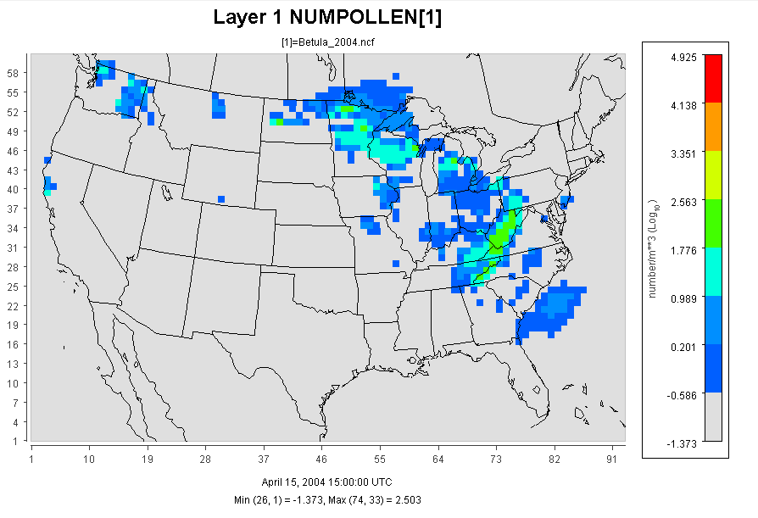

Figure 1 using VERDI

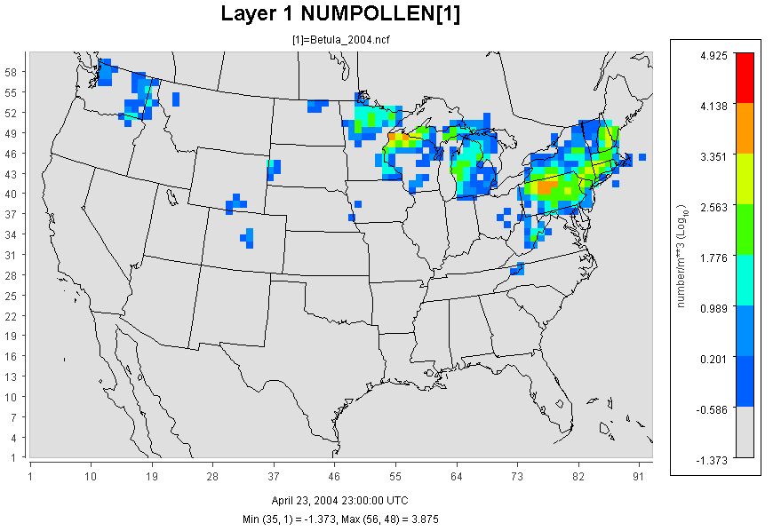

Figure 2 using VERDI

We used the time-average data to simulate the pollen distribution through the flowering season. The distribution is shown in figure 2.

Figure 2 using Matlab

**Exposure Method Selection**

**1 Inhalation**

Exposure can be quantified by multiplying the concentration of an agent times the duration of the contact. Exposure can be instantaneous when the contact between an agent and a target occurs at a single point in time and space .The summation of instantaneous exposures over the exposure duration is called the time-integrated exposure (Zartarian et al., 2007). Equation shows the time-integrated exposure.

*E= $\int{C(t)dt}$*

where: E = Time-integrated exposure (mass/volume),

t2– t1 = Exposure duration (ED) (time),

C = Exposure concentration as a function of time (mass/volume).

Dividing the time-integrated exposure by the exposure duration, results in the time-averaged exposure

In this paper, since the time step is 1 hour, we integrated the concentration through the whole flowering season (an average time about 200 hours),and we use numbers of pollen instead of the concentration which would be more reasonable in investigating the effect of pollen.

The Exposure Factors Data are from Exposure Factor Handbook 2011

The Population Data are from U.S Census Bureau: Age and Sex Composition:2010

**2 Dermal Exposure**

Dermal exposure to volatile chemical compound is fully studied already, however, the reports to the dermal exposure to pollen remains rare. We use dry deposition model to estimate the adherence of pollen to human skins.

The dry deposition model assumed that the transport of material to the surface is to be governed by three resistances in series: the aerodynamic resistance $r_{a}$

, the quasi-laminar layer resistance $r_{b}$, and the surface or canopy resistance $r_{c}$.The total resistance, $r_{t}$ by definition, the inverse of the deposition velocity

$v_{d}^{-1}=r_{a}+r_{b}+r_{c}$

For particle dry deposition, $v_{d}$ becomes

$v_{d}=v_{s}+\frac{1}{r_{a}+r_{b}+r_{a}*r_{b}*v_{s}}$

While $v_{s}$ is the particle settling velocity

$$r_{a}=\frac{1}{ku_{*}}\ln\left(\frac{z}{z_{0}}\right)$$

$$r_{b}=1/(u_{*}(Sc^{-\frac{2}{3}}+{10}^{-\frac{3}{St}})$$

$$v_{s}=\frac{ρ_{p}D_{p}^{2}gC_{c}}{18μ}$$

$$C_{c}=1+\frac{2λ}{D_{p}}\left(1.257+0.4e^{-\frac{0.55Dp}{λ}}\right)$$

Where $ρ_{p}$ is the density of the particle, $D_{p}$ is the particle diameter, g is the gravitational acceleration, μ is the viscosity of air, and $C_{c}$ is the slip correction factor.

$$Sc=\frac{μ}{ρ_{a}D}$$

$$St=\frac{v_{s}u_{*}^{2}ρ_{a}}{gμ}$$

$$D=\frac{k_{B}TC_{C}}{3πμD_{p}}$$

Where Sc is the Schmidt number, St is the Stokes number, and D is the molecular diffusivity,

So the direct deposition to the skin can be calculated now

1 indoor

$$M_{su}=A_{skin}v_{d} \int{C\left(t\right)dt}$$

2 outdoor

$$M_{su}=\frac{A_{skin}v_{d}λ_{v}}{λ_{v}+λ_{d}}\int{C\left(t\right)dt}$$

Where $M_{su}$ is the mass of the substance in the skin surface is, $A_{skin}$ is the exposed skin area.

The parameters $λ_{d}$ $λ_{v}$ are ventilation rate and indoor deposition velocity, respectively.

**Sensitivity Analysis**

Sensitivity analysis is the analysis of how the uncertainty in the output of a mathematical system or modeling(numerical or otherwise) can be apportioned to variety sources of uncertainty in its inputs.[1] A similar test is uncertainty analysis, which mainly focus on uncertainty quantification and propagation of uncertainty.

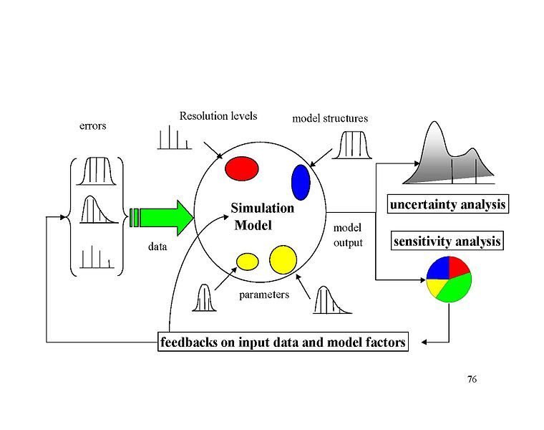

sensitivity analysis,Andrea Saltelli

Mean daily mass intake exposure to pesticide was selected as a metric for testing the system’s sensivity to multiple inputs and parameters.Global sensitivity analysis were performed based on Morri’s Design. This design estimate the main effect of a parameter by computing a number of local sensitivities at random points of the parameter space.The mean of these randomized local sensitivities indicates the overall influence of a given parameter on the output metric,while the corresponding standard deviation indication the effects of interacting and nonlinearity.

In the current study,each of the 17 parameters(Table 1) was sampled 3600 times according to the Morris method from 200 trajectories (each has 18 steps) in the parameter space. Each of the paramters in the simulation was perturbed from 50% to 150% of its base value or its distribution while we keep other parameters unchanged in the same time.

The mean daily exposure for sensitivity analyses was normally generated using 10000 “virual men” in each climate zones in the flowering season.Equation was used to calculate the Normalized Sensitivity Coefficients(NSC) at a local point.

There are a great number of methods to performing a sensitivity analysis, many of which have been developed to address one or more of the constraints discussed above.[[1]](http://en.wikipedia.org/wiki/Sensitivity_analysis#cite_note-Primer-1)They are also distinguished by the type of sensitivity measure, be it based on (for example) [variance decompositions](http://en.wikipedia.org/wiki/Variance-based_sensitivity_analysis), [partial derivatives](http://en.wikipedia.org/wiki/Partial_derivatives) or [elementary effects](http://en.wikipedia.org/wiki/Elementary_effects_method). In general, however, most procedures adhere to the following outline:

1. Quantify the uncertainty in each input (e.g. ranges, probability distributions). Note that this can be difficult and many methods exist to elicit uncertainty distributions from subjective data.[[7]](http://en.wikipedia.org/wiki/Sensitivity_analysis#cite_note-7)
2. Identify the model output to be analysed (the target of interest should ideally have a direct relation to the problem tackled by the model).
3. Run the model a number of times using some [design of experiments](http://en.wikipedia.org/wiki/Design_of_experiments),[[8]](http://en.wikipedia.org/wiki/Sensitivity_analysis" \l "cite_note-8) dictated by the method of choice and the input uncertainty.
4. Using the resulting model outputs, calculate the sensitivity measures of interest.

In some cases this procedure will be repeated, for example in high-dimensional problems where the user has to screen out unimportant variables before performing a full sensitivity analysis.

This section discusses various types of "core methods", distinguished by the various sensitivity measures that are calculated (note that some of these categories "overlap" somewhat). The following section focuses on alternative ways of obtaining these measures, under the constraints of the problem.

### One-at-a-time (OAT/OFAT)[

One of the simplest and most common approaches is that of changing one-factor-at-a-time, to see what effect this produces on the output.[[9]](http://en.wikipedia.org/wiki/Sensitivity_analysis#cite_note-9) [[10]](http://en.wikipedia.org/wiki/Sensitivity_analysis#cite_note-10) [[11]](http://en.wikipedia.org/wiki/Sensitivity_analysis#cite_note-11) OAT customarily involves:

* Moving one input variable, keeping others at their baseline (nominal) values, then,
* Returning the variable to its nominal value, then repeating for each of the other inputs in the same way.

Sensitivity may then be measured by monitoring changes in the output, e.g. by [partial derivatives](http://en.wikipedia.org/wiki/Partial_derivatives) or [linear regression](http://en.wikipedia.org/wiki/Linear_regression). This appears a logical approach as any change observed in the output will unambiguously be due to the single variable changed. Furthermore, by changing one variable at a time, one can keep all other variables fixed to their central or baseline values. This increases the comparability of the results (all ‘effects’ are computed with reference to the same central point in space) and minimizes the chances of computer programme crashes, more likely when several input factors are changed simultaneously. OAT is frequently preferred by modellers because of practical reasons. In case of model failure under OAT analysis the modeller immediately knows which is the input factor responsible for the failure.[[5]](http://en.wikipedia.org/wiki/Sensitivity_analysis#cite_note-OAT-5)

Despite its simplicity however, this approach does not fully explore the input space, since it does not take into account the simultaneous variation of input variables. This means that the OAT approach cannot detect the presence of [interactions](http://en.wikipedia.org/wiki/Interaction_(statistics)) between input variables.[[12]](http://en.wikipedia.org/wiki/Sensitivity_analysis#cite_note-12)

**3 Result and Discussion**

The exposure duration t can be set to different values for assessing exposure associated with different time durations. For example, it can be set to 1 hour to 24 hour to asses hourly to daily exposures.

The exposure effect is shown as below

The data is from 9 nine climate zone which

Table S1,Parameters for calculating population exposure to pollens in 9 different climate zones in United States.These parameters were listed either as fixed valueds,known distribtuons or unkown empirical distribution derived from the literatures.

|  |  |  |  |  |  |
| --- | --- | --- | --- | --- | --- |
| **Parameter** | **Parameter ID** | **Distribution** | **Mean(STD)** | **Range** | **Ref.** |
| friction velocity(m/s) | 1 | fix | 1.17 | - |  |
| von karman constant(dimensionless) | 2 | fix | 0.41 | - |  |
| diameter of pollen(m) | 3 | fix | 0.00002 | - |  |
| density of pollen(kg/m3) | 4 | fix | 840 | - |  |
| viscosity of air (m/s) | 5 | fix | 0.0000181 | - |  |
| mean free path of air molecules(m) | 6 | fix | 6.8E-08 | - |  |
| density of air(kg/m3) | 7 | fix | 1.145 | - |  |
| temperature(k) | 8 | range | 298 | 283-310 |  |
| ventilation rate(dimensionless) | 9 | range |  | - |  |
| indoor time(min) | 10 | norm | 1279(21) | - |  |
| outdoor time(min) | 11 | norm | 174(4) | - |  |
| hand to mouth contact frequency | 12 | empirical | 30 | 3-65 |  |
| human surface area(m2) | 13 | lognorm | 1.76 | 0.41-2.51 |  |
| hand surface rate(%) | 14 | lognorm | 5.3 | 4.8-5.6 |  |
| inhalation rate (m3/day) | 15 | uniform | 1.33 | 0.19-1.91 |  |
| inhalation rate(m3/day) | 16 | uniform | 1.45 | 0.20-1.50 |  |
| indoor velidation rate(dimensionless) | 17 | empirical | 1.75 | - |  |

Figure3(1-9) Mean and Standard Deviation of Normalized Sensitvity Coefficient(NSC) for population exposure in 9 different climate zones. (A) Inhalation (B)Dermal (C)Total Exposures

Figure Mean and Standard Deviation of Normalized Sensitvity Coefficient(NSC) for population exposure in the united states( 9 zones combined data) (A) Inhalation (B)Dermal (C)Total Exposures 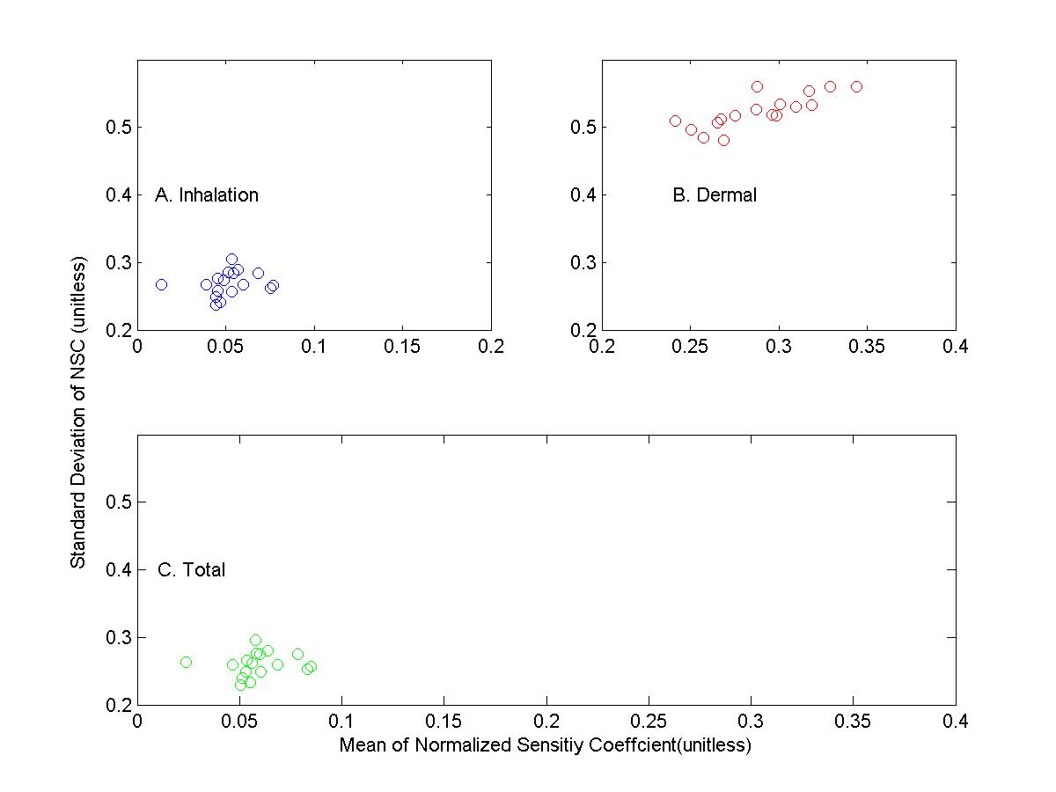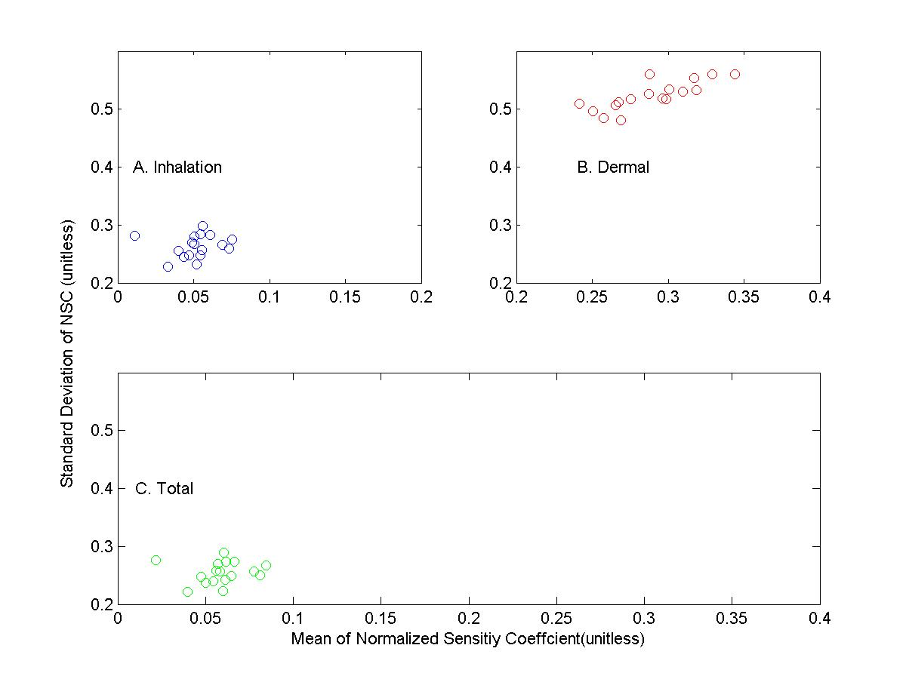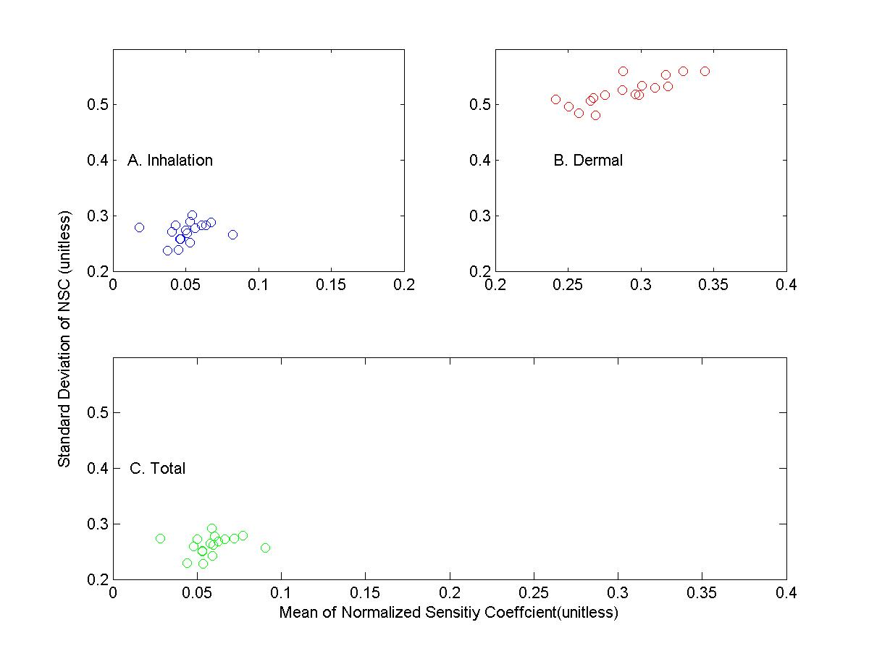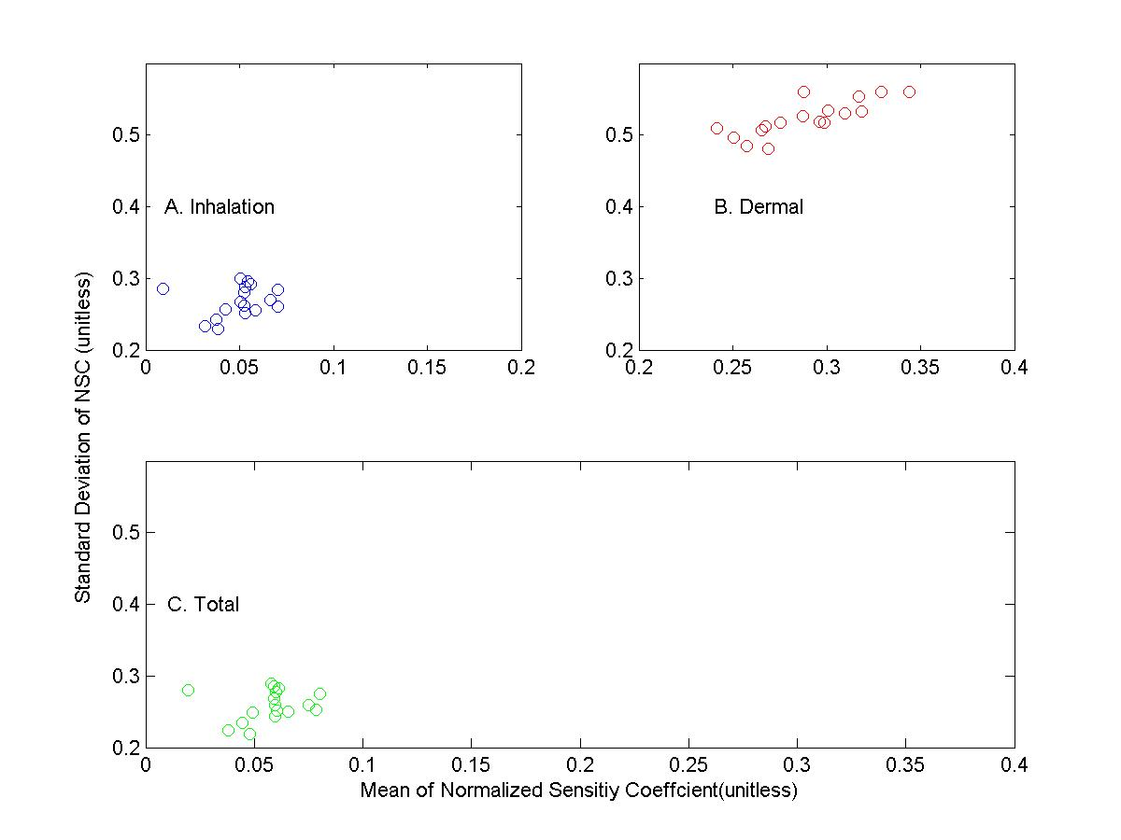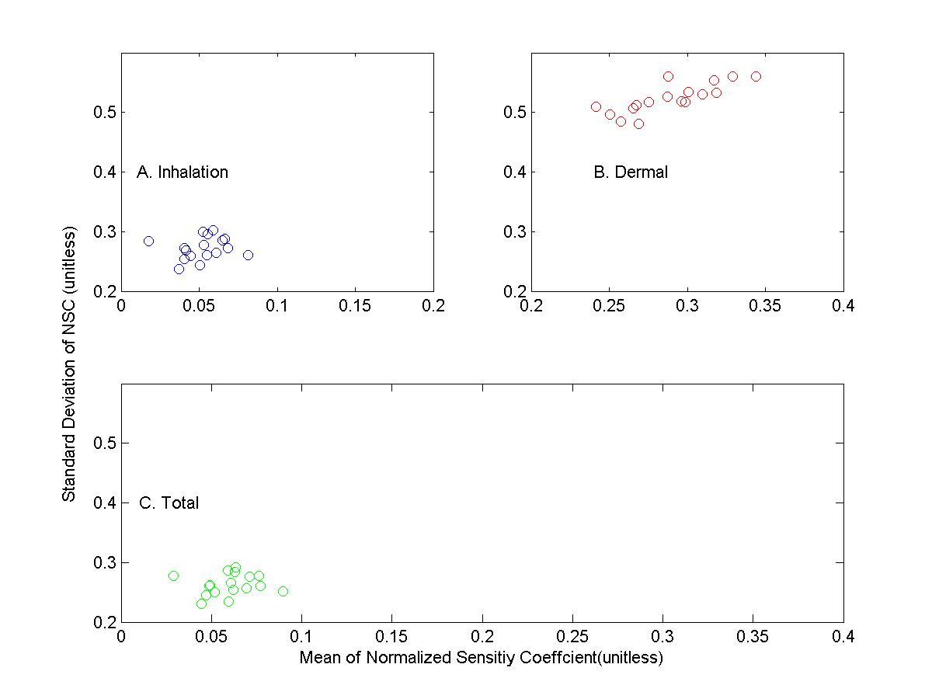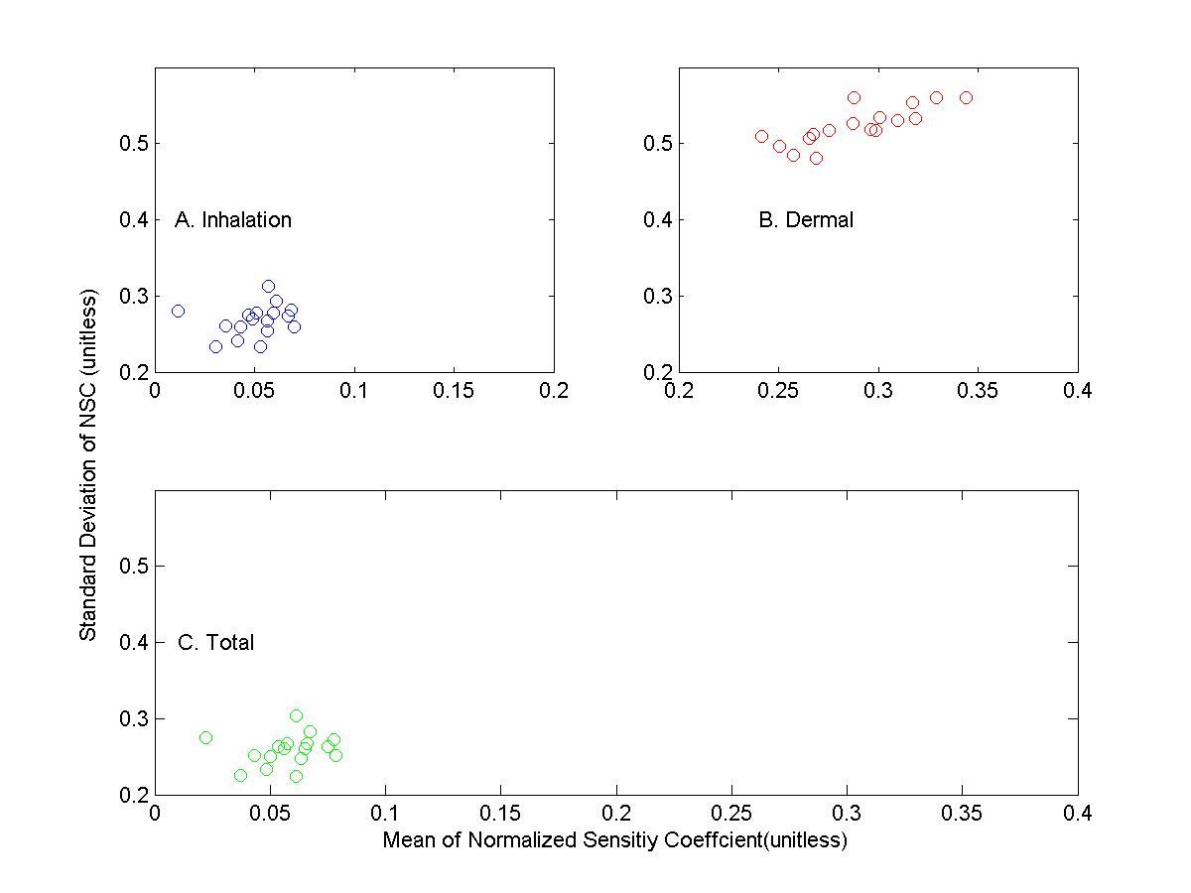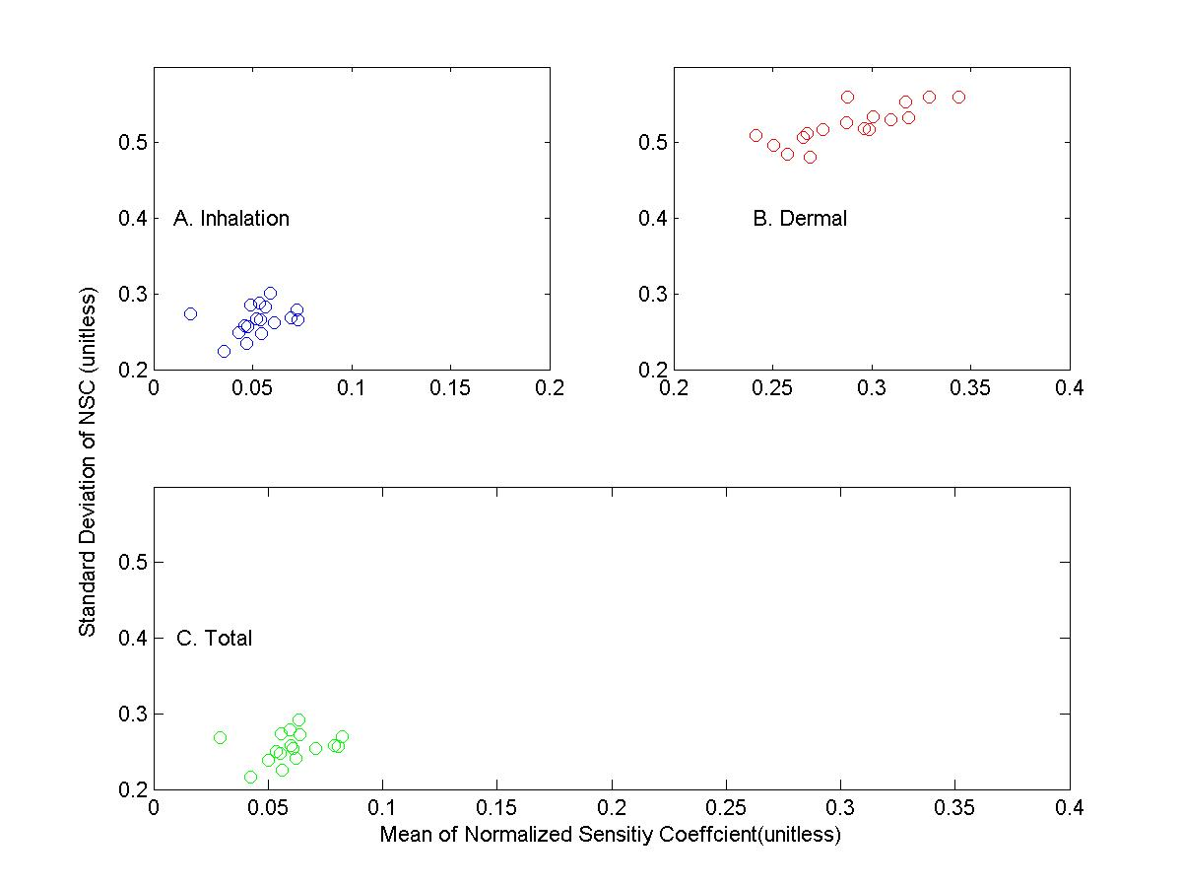 Figure Mean and Standard Deviation of Normalized Sensitvity Coefficient(NSC) for population exposure in the united states( 9 zones combined data) (A) Inhalation (B)Dermal (C)Total Exposures 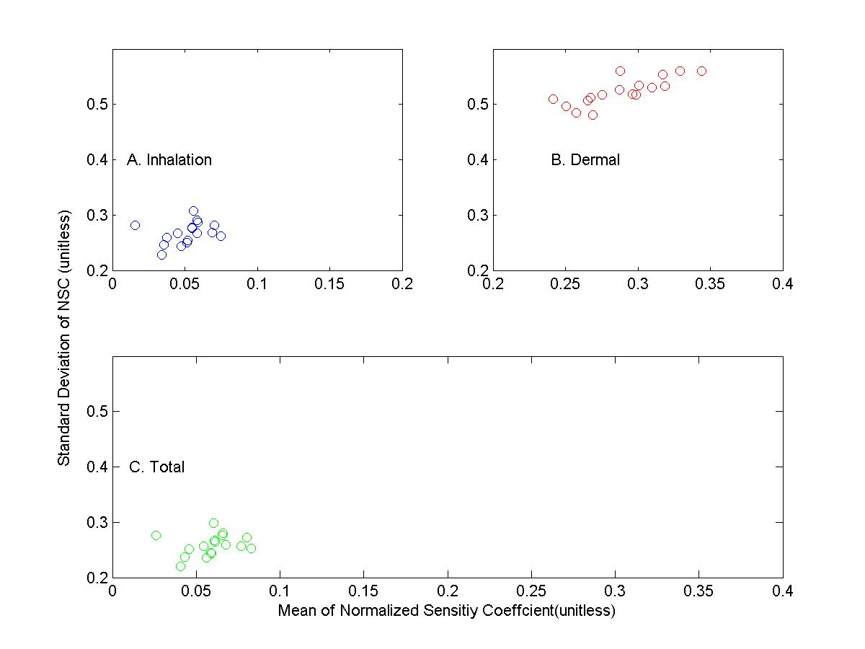 Figure Mean and Standard Deviation of Normalized Sensitvity Coefficient(NSC) for population exposure in the united states( 9 zones combined data) (A) Inhalation (B)Dermal (C)Total Exposures 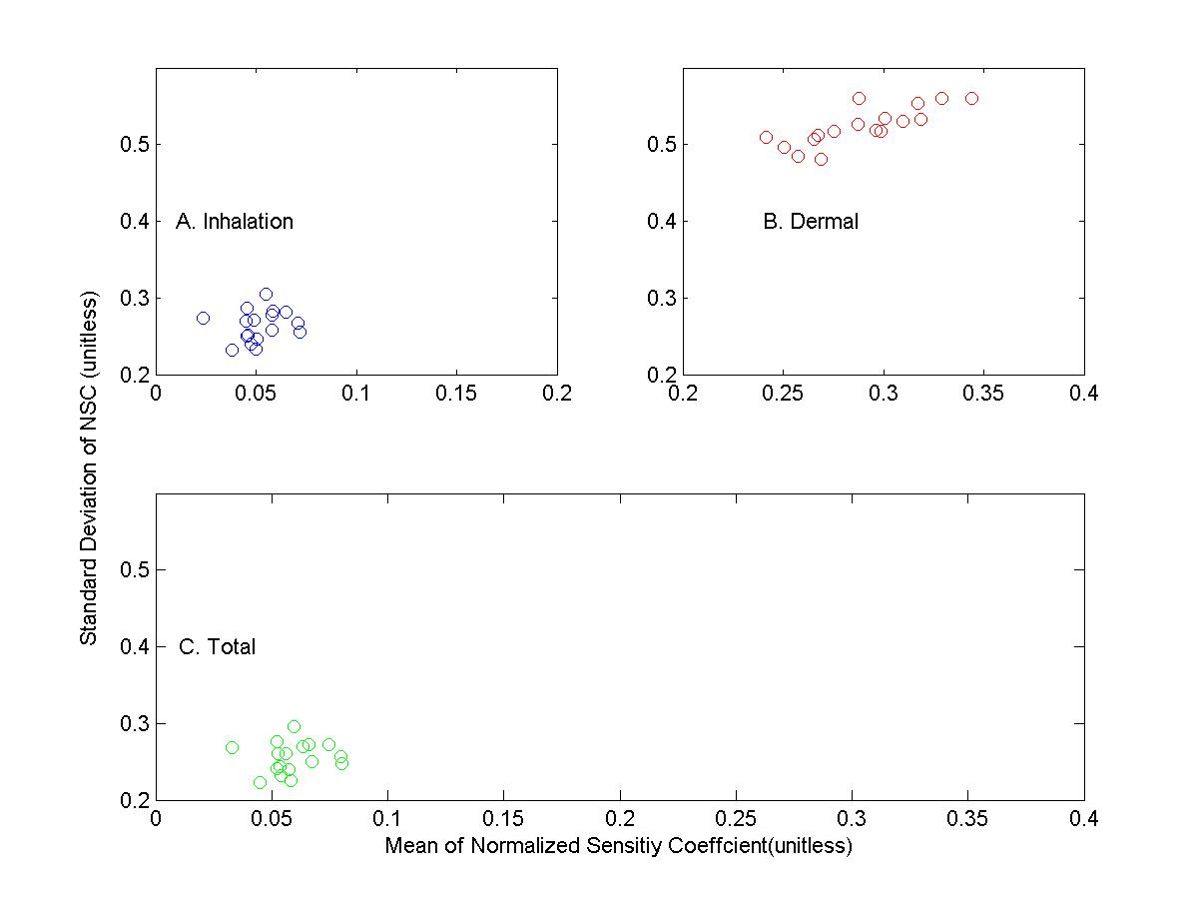

Figure Mean and Standard Deviation of Normalized Sensitvity Coefficient(NSC) for population exposure in the united states( 9 zones combined data) (A) Inhalation (B)Dermal (C)Total Exposures

Figure S1

Schematic diagram of modeling occupational exposure of population exposure to pollens in 9 climate zones.Concernrations and surface loading of pollens were simulated based on mass balance and sourece concerntraion from fluid dynamic model.Exposures to pollens were simulated based on the concentration profiles and activity data of different groups by ages and sex from United States Census Bureau.The intake dosed calculated from exposure modeling are then used as input to conduct sensitivity analysis.



The modeling system developed based on physical processes and human activity data in the current study,can be easily adapted to simulated risks and exposure to particulate matter(PM) in similar environments or small scaled units such as cities or certain census.Furthermore,sensitivity analyses of the modeling system provides helpful information for planning measurements related to investigation of health risks associated with occupational exposures to pollens or other kinds or particulate particles in the environments.